TESTING 4 – 1

only Review MicroService Down

1)Order

GET

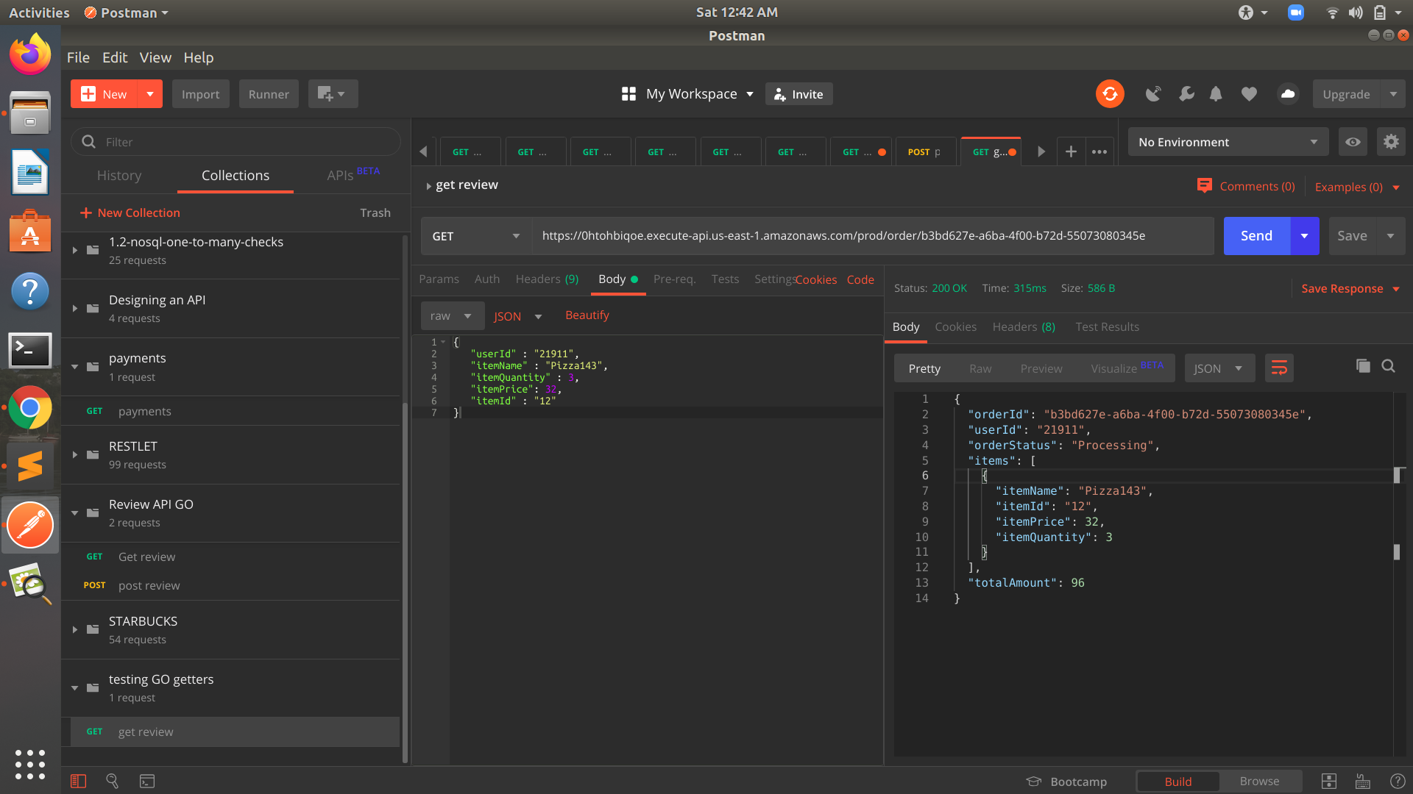

Post

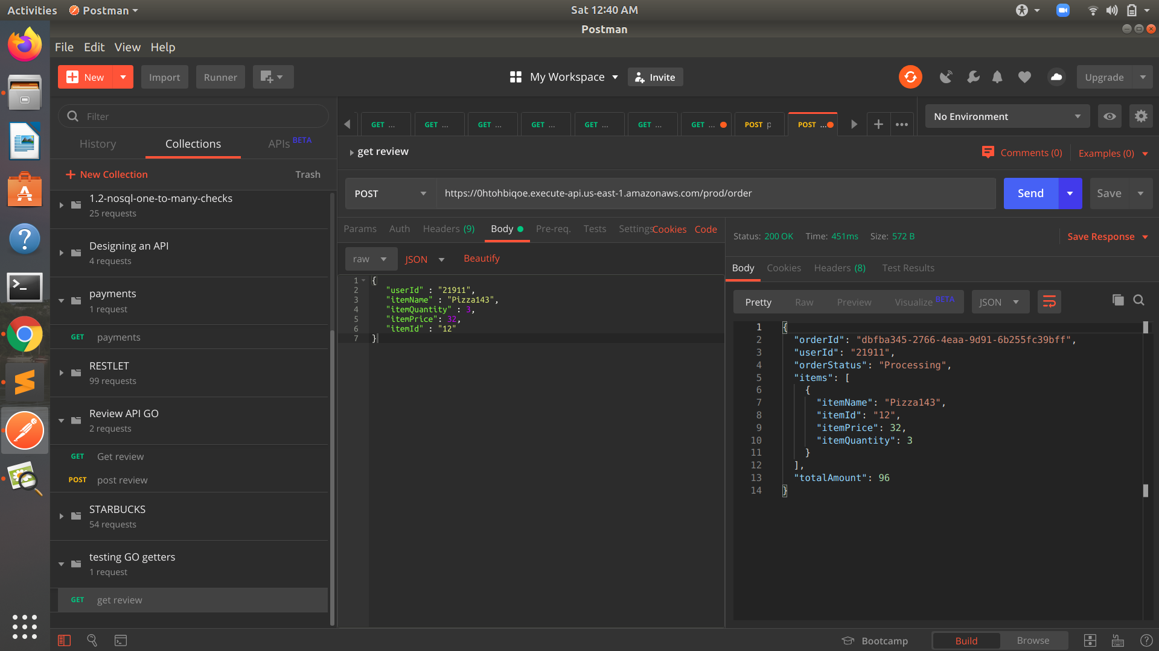

2)Menu

GET

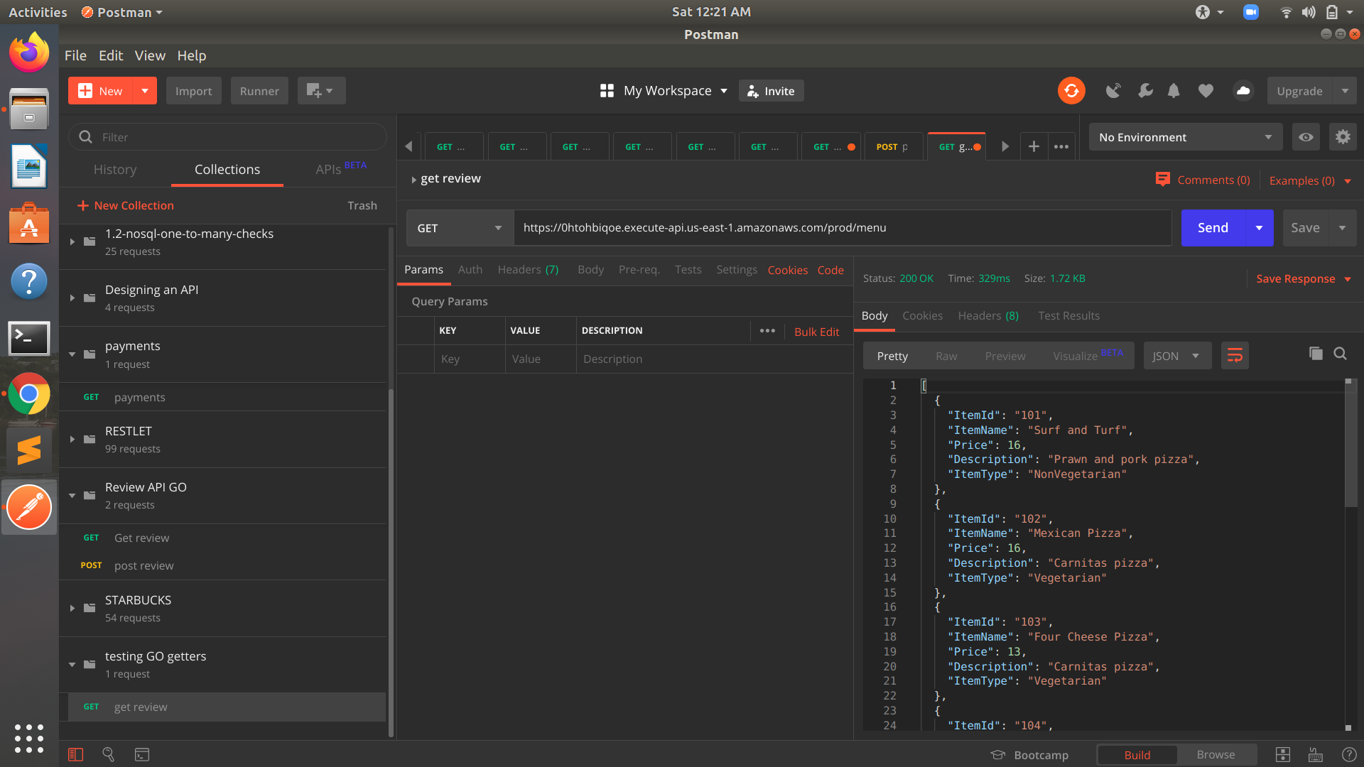

3)Payments

Post

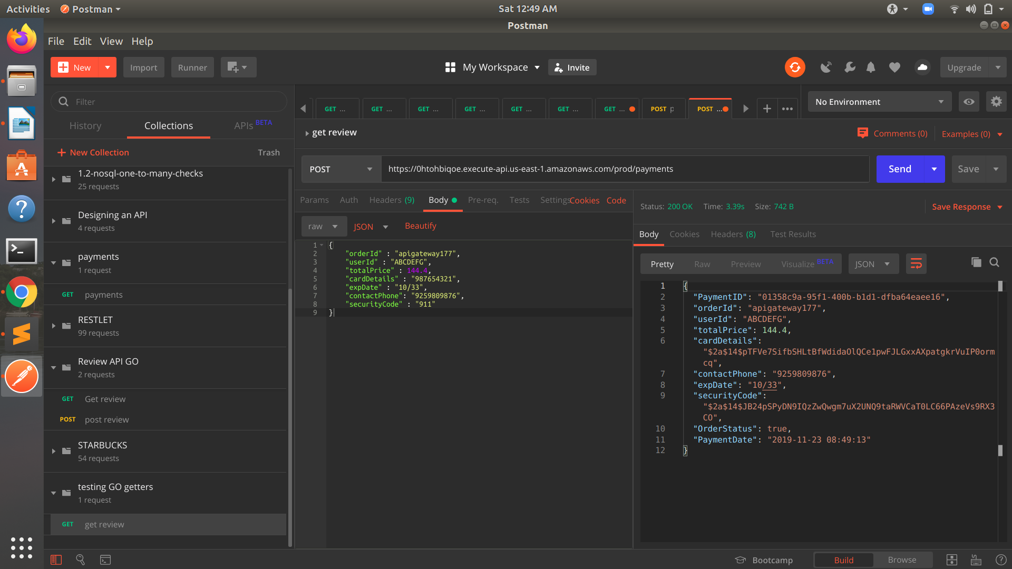

4)Review

GET

